We love messing around with R to generate mathematical patterns. Its always get surprised doing it and gives me lot of satisfaction. Also learn lot of things doing it: not only about R, but also about mathematics. It is one of my favourite hobbies. Some time ago,

This Summer Its delved into this concept of *Tweetable Art* publishing several drawings together with the R code to generate them. In this post , will show some.

**Vertiginous Spiral**

It came up with this image inspired by this nice pattern. It is a turtle graphic inspired pattern but instead of drawing lines I use geom_polygon to colour the resulting image in black and white:

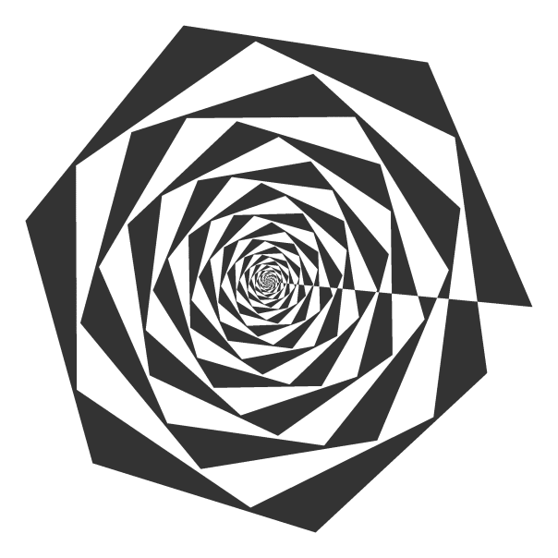

Code:

library(tidyverse)

df <- data.frame(x=0, y=0)

for (i in 2:500){

df[i,1] <- df[i-1,1]+((0.98)^i)*cos(i)

df[i,2] <- df[i-1,2]+((0.98)^i)*sin(i)

}

ggplot(df, aes(x,y)) +

geom_polygon()+

theme_void()

Slight modifications of the code can generate appealing patterns like this:

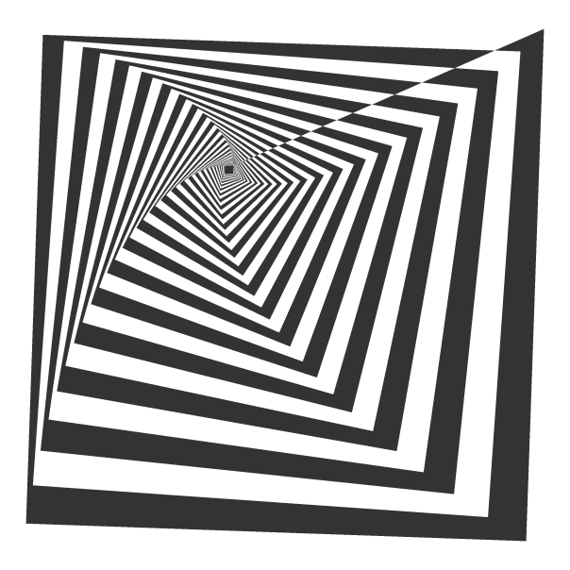

**Marine Creature**

A combination of sines and cosines. It reminds me a jellyfish:

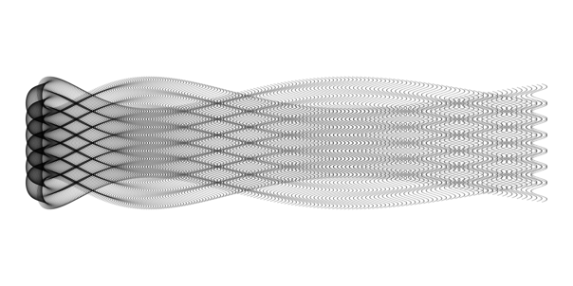

Code:

library(tidyverse)

seq(from=-10, to=10, by = 0.05) %>%

expand.grid(x=., y=.) %>%

ggplot(aes(x=(x^2+pi*cos(y)^2), y=(y+pi*sin(x)))) +

geom_point(alpha=.1, shape=20, size=1, color="black")+

theme_void()+coord_fixed()

**Summoning Cthulhu**

It is a modification of the marine creature in polar coordinates:

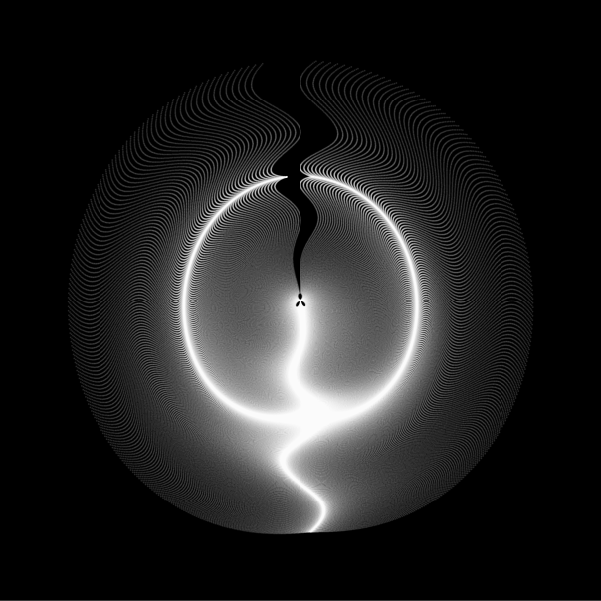

Code:

library(tidyverse)

seq(-3,3,by=.01) %>%

expand.grid(x=., y=.) %>%

ggplot(aes(x=(x^3-sin(y^2)), y=(y^3-cos(x^2)))) +

geom_point(alpha=.1, shape=20, size=0, color="white")+

theme_void()+

coord_fixed()+

theme(panel.background = element_rect(fill="black"))+

coord_polar()

**Naive Sunflower**

Sunflowers arrange their seeds according a mathematical pattern called phyllotaxis, whic inspires this image. If you want to create your own flowers, you can do [this Datacamp’s project](https://www.datacamp.com/projects/62?tap_a=5644-dce66f&tap_s=10907-287229). It’s free and will introduce you to the amazing world of ggplot2, my favourite package to create images:

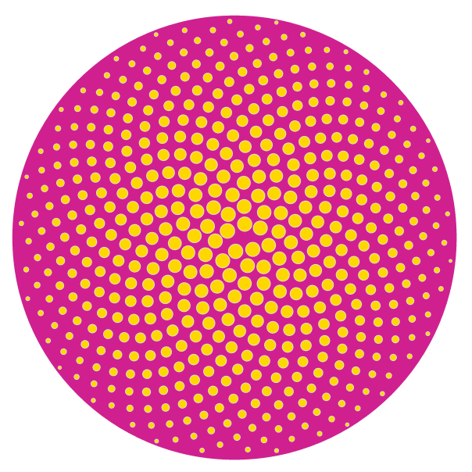

Code:

library(ggplot2)

a=pi*(3-sqrt(5))

n=500

ggplot(data.frame(r=sqrt(1:n),t=(1:n)*a),

aes(x=r*cos(t),y=r*sin(t)))+

geom_point(aes(x=0,y=0),

size=190,

colour="violetred")+

geom_point(aes(size=(n-r)),

shape=21,fill="gold",

colour="gray90")+

theme_void()+theme(legend.position="none")

**Silk Knitting**

A lot of *almost transparent* white points ondulating according to sines and cosines on a dark coloured background:

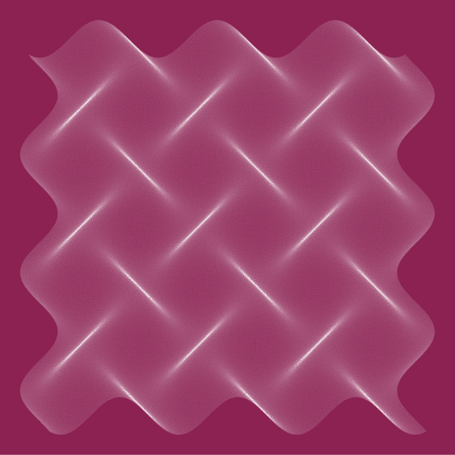

Code:

library(tidyverse)

seq(-10, 10, by = .05) %>%

expand.grid(x=., y=.) %>%

ggplot(aes(x=(x+sin(y)), y=(y+cos(x)))) +

geom_point(alpha=.1, shape=20, size=0, color="white")+

theme_void()+

coord_fixed()+

theme(panel.background = element_rect(fill="violetred4"))

Try to modify them and generate your own patterns: it is a very funny way to learn R.

**Note:** in order to make them better readable, some of the pieces of code below may have more than 280 characters but removing unnecessary characters (blanks or carriage return) you can reduce them to make them tweetable.